Name

Mathematics Stage 5 Core
Compound Interest &
Depreciation

Book 1 | Solve problems involving  compound interest and depreciation | Version: 260210  Feedback:  https://MrDingMaths.com
Contents
Syllabus Content 2
Learning Intention Error! Bookmark not defined.

Syllabus Content
MA5-FIN-C-02 solves financial problems involving compound interest and depreciation
Solve problems involving compound interest and depreciation
- Examine compound interest for up to 3 time periods using repetition of the formula for simple interest
- Associate the calculation of the total value of a compound interest investment with repeated multiplication, using digital tools
- Establish and use the formula $FV=PV{\left(1+r\right)}^{n}$ to find compound interest where $FV$ $=$ future value of the investment, $PV=$ present value of the investment, $r=$interest rate per time period and $n=$ number of time periods
- Solve problems involving compound interest
- Compare simple interest with compound interest in practical situations
- Use the compound interest formula to establish the depreciation formula $S=V_{0}{\left(1-r\right)}^{n}$where $S=$ salvage value, $V_{0}=$initial value of the asset, $r=$ depreciation rate per time period and $n=$ number of periods
- Solve problems involving the depreciation of an asset

Investigation Compound Interest

- Investigation Comparing simple and compound interest.
Simple interest is calculated as a percentage of the principal only.
Compound interest is a percentage of the current total, including previous interest.
$1000 is invested in a savings account at a simple interest rate of 10% per annum.
Year | Starting Balance | Interest | Ending Balance
1 | $1000 | $$1000×0.1=100$$ | $1100
2 | $1100
3
4

The interest earned is: $…………… $-\$1000=$ $……………

$1000 is invested in a savings account at a compound interest rate of 10% per annum.
Year | Starting Balance | Interest | Ending Balance
1 | $1000 | $$1000×0.1=100$$ | $1100
2 | $1100
3
4

The interest earned is: $…………… $-\$1000=$ $……………

Simple interest is a percentage of the ………………….. only,
Compound interest is a percentage of the principal and the ……….............. earned so far.
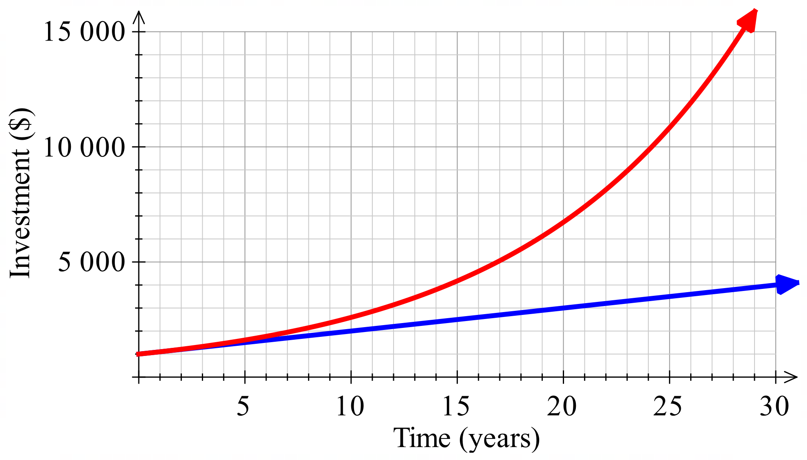
Simple
Compound

The graph of simple interest is a …………………-line.
The graph of compound interest is an ……………………… curve.

Foundation
- $2400 is invested at 6% p.a. compound interest for 3 years.
  - Complete the table to find the final value at the end of 3 years.
Year | Starting Balance | Interest | Ending Balance
1 | $2400 | $$2400×0.06=144$$ | $2544
2 | $2544
3
$2858.44
  - Calculate the interest earned.
$…………… $-\$2400=$ $……………
$458.44
- $3600 is invested at 5% p.a. compound interest for 3 years.
  - Complete the table to find the final value at the end of 3 years.
Year | Starting Balance | Interest | Ending Balance
1 | $3600
2
3
$4167.45
  - Calculate the interest earned.

$567.45

- Alison invests $7890 at 8.9% p.a. compound interest for 5 years.
  - Complete the table to find the final value at the end of 5 years.
Year | Starting Balance | Interest | Ending Balance
1
2
3
4
5
$12 084.16

  - Will she have enough to buy a car worth $12000? If so, by how much?

Yes, by $84.16

- An amount of $10 000 is to be invested at 8.5% for 5 years.
  - Complete the table if invested as simple interest.
Year | Starting Balance | Interest | Ending Balance
1 | $10 000
2
3
4
5
$14 250
  - Complete the table if invested as compound interest.
Year | Starting Balance | Interest | Ending Balance
1 | $10 000
2
3
4
5
$15 036.57

  - Draw the two graphs on the same axis to show how the value of the investment changes for each option over the 5 years.
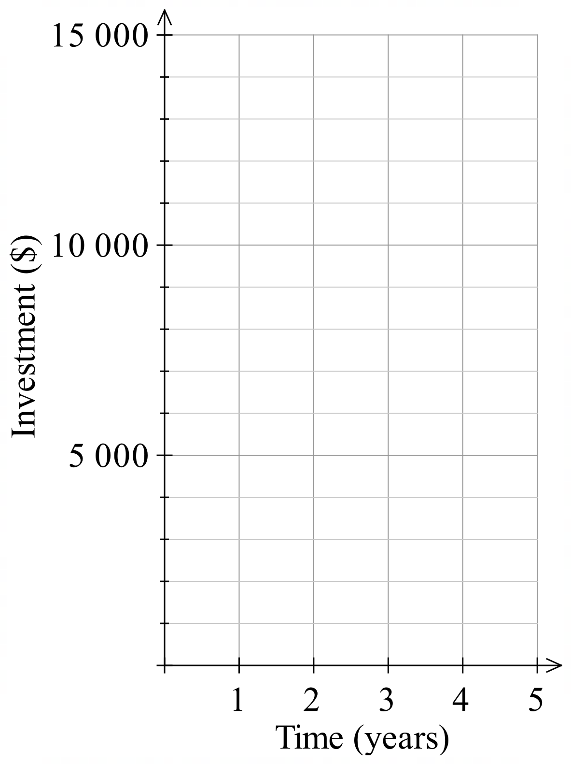

Compound Interest Formula

- Investigation the compound interest formula
$1000 is invested at a compound interest rate of 10% p.a.
Complete this table.
Years | Starting Balance | Interest paid that year | Ending Balance
1 | $$\$1000$$ | $$1000×10\%$$ | $$\$1100$$
2 | $$\$1100$$ | $$1100×10\%$$
3

Every year, the ending balance increases by 10%, which means multiplying by 1.1.
After 1 year, $A=\$1000×1.1$
After 2 years, $A=\$1000×1.1×1.1$
After 3 years, $A=\$1000×$ …. $×$ …. $×$ ….
If you were to write the ending balance after 6 years, it would be:
$A=\$1000×$ …… $×$ …… $×$ …… $×$ …… $×$ …… $×$ ……
$=\$1000×{\left( \right)}^{…}$

If you were to write the ending balance after $n$ years, it would be:
$A=\$1000×{\left( \right)}^{…}$

For any initial amount $P$, and interest rate $r$, the ending balance after $n$ years would be:
$A=$ ……… $×$ ${\left(1+ \right)}^{…}$

- Key Ideas
- Simple interest is a percentage of the …………………… only.
- Compound interest is a percentage of the principal, plus any existing ……………………
- Compound interest increases …………………… than simple interest.

- Compound Interest Future Value Formula
The initial amount (principal) is called the present value (PV).
The final amount after growth is the future value (FV).

$\begin{matrix}present \\ value\end{matrix}$ $\begin{matrix}number of \\ periods\end{matrix}$

$$FV=PV{\left(1+r\right)}^{n}$$

$\begin{matrix}future \\ value\end{matrix}$ $\begin{matrix}interest rate \\ per period\end{matrix}$

- Example Calculate future value using the compound interest formula
$PV$ $r=0.07$
$2000 is invested at 7% p.a. compounded annually.
Calculate the amount $2000 will grow to after 3 years.
$n$
$FV=PV{\left(1+r\right)}^{n}$
$=\$2000{\left(1+0.07\right)}^{3}$
$=\$2450.09$

- Guided Practice
- Find the value of an investment of $2500 over 2 years at 5% p.a. compounded annually.  $FV=PV{\left(1+r\right)}^{n}$  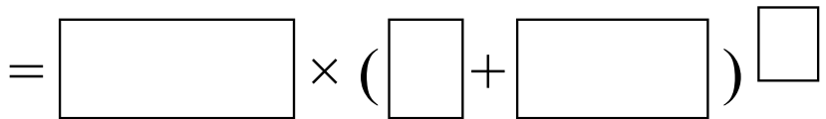  $=$ …………………  $2756.25 | - $12 500 is invested over 7 years, compounded annually at 9.8% p.a.  Find the future value.  $24 050.63

- Compound Interest Formula
We subtract the present value from the future value to find the compound interest.

$\begin{matrix}future \\ value\end{matrix}$

$$I=FV-PV$$

$Interest$ $\begin{matrix}present \\ value\end{matrix}$

- Example Calculate compound interest
$PV$ $n$ $r=0.05$
$3000 is invested for 4 years at 5% p.a. compounded annually.
Calculate the amount of interest earned.
$FV=PV{\left(1+r\right)}^{n}$  $=\$3000{\left(1+0.05\right)}^{4}$  $=\$3646.52$ | $I=FV-PV$  $=\$3646.52-\$3000$  $=\$646.52$

- Guided Practice
- Find the future value of an investment of $3500 over 7 years at 6.2% p.a. compounded annually.  $FV=PV{\left(1+r\right)}^{n}$  $=$ …………………  Calculate the interest earned.  $I=FV-PV$  $=$ …………………$-$ …………………  $=$ ………………………………………  $1832.61 | - An investment of $4000 is compounded at 7.5% p.a. over 6 years.  Calculate the interest earned.  $2173.21

- Example Calculate present value in a compound interest scenario
$n$ $r=0.09$
An amount of money was invested for 5 years at 9% p.a. compounded annually.
The final value at the end of 5 years was $24617.98. $FV$
Find the amount invested at the start, to the nearest dollar.

$FV=PV{\left(1+r\right)}^{n}$
$24617.98=PV{\left(1+0.09\right)}^{5}$
$$\frac{24617.98}{{\left(1+0.09\right)}^{5}}=PV$$
$PV≈\$16000$

- Guided Practice
- Find the present value of an investment if the final value after 6 years at 4% p.a. compounded annually is $2340.84.  $FV=PV{\left(1+r\right)}^{n}$  $1850 | - Jess has $27620.10 in her investment account. This was the result of 7.8% p.a. compounded annually over 6 years. Find how much she invested 6 years ago.  $17600

Foundation
- $5000 is invested for 3 years at 4% p.a. interest, compounded yearly. Fill in the table.
Year | Starting Balance | Interest | Ending Balance
1 | $5000 | $5000×0.04=$
2 | $5200
3
  - Using the table, what is the balance at the end of year 3?
$5624.32
  - Calculate the answer to part a using the future value formula.
$FV=PV{\left(1+r\right)}^{n}$
$=$ ……………………………………
Same value as part a
- Calculate the future value of a $650 investment at 6% p.a. for 5 years compounded annually.

$FV=PV{\left(1+r\right)}^{n}$
$=$ ……………………………………
869.85
- $700 invested at 8% p.a. compounded annually. Calculate the value at the end of 2 years.

$FV=PV{\left(1+r\right)}^{n}$
$=$ ……………………………………
$816.48
- $1000 invested at 15% p.a. compounded annually. Calculate the value at the end of 6 years.

$FV=PV{\left(1+r\right)}^{n}$
$=$ ……………………………………
$2,313.06

- Calculate the future value of an investment of $2000 over 2 years at 6% p.a. compounded annually.  $FV=PV{\left(1+r\right)}^{n}$  $=$ ……………………………………  $2247.20  Calculate the interest earned.  $I=FV-PV$  $=$ …………………$-$ …………………  $=$ ………………………………………  $247.20 | - Calculate the future value of an investment of $34 000 compounded at 24% p.a. over 4 years.  $FV=PV{\left(1+r\right)}^{n}$  $=$ ……………………………………  $80 383.27  Calculate the interest earned.  $I=FV-PV$  $=$ …………………$-$ …………………  $=$ ………………………………………  $46 383.27
- Calculate the amount after 5 years if $4000 is compounded annually at 5%.  $FV=PV{\left(1+r\right)}^{n}$  $=$ ……………………………………  $5 105.13  Calculate the interest earned.  $I=FV-PV$  $=$ …………………$-$ …………………  $=$ ………………………………………  $1 105.13 | - Calculate the amount after 3 years if $100 000 is compounded at 6% p.a.  $FV=PV{\left(1+r\right)}^{n}$  $=$ ……………………………………  $119 101.60  Calculate the interest earned.  $I=FV-PV$  $=$ …………………$-$ …………………  $=$ ………………………………………  $19 101.60

Development
- $8400 is invested for 3 years at 6% p.a. interest, compounded yearly.
  - Calculate the value of the investment after 3 years.

$10 004.53
  - What is the total amount of interest earned?

$1604.53
- $14 200 is invested for 2 years at 2.9% p.a. interest, compounded yearly.
  - Calculate the value of the investment after 2 years.

$15 035.54
  - What is the total amount of interest earned?

$835.54
- Find the present value of money in a bank account if the future value after 4 years earning 9% p.a. compound interest, paid annually, is $5000. Answer to the nearest dollar.

$3 542
- What sum of money would Max need to invest to accumulate a total of $100 000 at the end of 7 years at 8% p.a. interest compounding annually? Answer to the nearest cent.

$58 349.04
- What sum of money needs to be invested to accumulate a total of $40 000 after 10 years at 9.25% p.a. interest compounding annually? Answer to the nearest cent.

$16 513.74
- Calculate the amount to which $11 000 will grow in 3 years if it is invested at 8% p.a.
  - simple interest

$13 640
  - compound interest.

$13 856.83
  - Which method of calculating interest produces the greater amount and by how much?

Compound interest produces $216.83 more than simple interest
- Calculate the amount to which $30 000 will grow in 4 years if it is invested at 5.6% p.a.
  - simple interest

$36 720
  - compound interest.

$37 305.85
  - Which method of calculating interest produces the greater amount and by how much?

Compound interest produces $585.85 more than simple interest

- Find 40% of $3920  $1568 | - Increase $3920 by 40%  $5488
- A number is increased by 40% to get $3920. What was the number?  $2800 | - $3920 is invested at 40% p.a. compounded annually. How much money is there after 3 years?  $10 756.48
- Bobby invested $5000. The table shows his investment over the first 4 months.
What are the values of A and B?
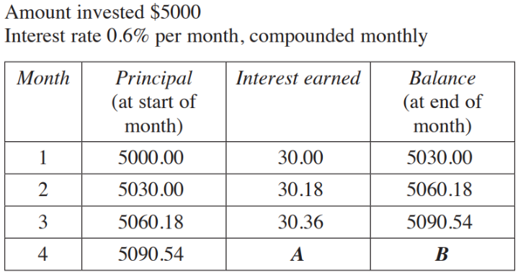

A = $30.54, B = $5121.08

Mastery
- $16 000 is invested for 5 years at 8% compounded annually.
  - Find the total interest earned over the 5 years to the nearest cent.
$$FV=16000{\left(1.08\right)}^{5}=23509.25$$
$I=FV-PV=\$7509.25$
  - Find the simple interest rate that would deliver the same overall interest at the end of the 5 years. Round to 2 decimal places.

$$I=Prn$$
$$7509.25=16000×r×5$$
$r=9.39\%$
- $100 000 is invested for 10 years at 5.5% compounded annually.
  - Find the total percentage increase in the investment to 2 decimal places.

$$FV=100 000{\left(1.055\right)}^{10}=170 814.45$$
$$\frac{170 814.45}{100 000}×100=70.81\%$$
  - Find the simple interest rate that would deliver the same overall interest at the end of the 10 years. Round to 2 decimal places.

$$I=Prn$$
$$70 814.45=100 000×r×10$$
$$r=7.08\%$$
- A forgetful person lets a personal loan balance grow from $800 to $1440 with a compound interest rate of 12.5% p.a. Approximately how many years did the person forget about the loan?

$$1440=800{\left(1.125\right)}^{n}$$
By guessing and checking whole number values of $n$,
5 years
- Charlene wants to invest $10 000 long enough for it to grow to at least $20 000.
The compound interest rate is 8% p.a.
How many whole numbers of years does she need to invest the money for so that it grows to her $20 000 target?

$$20 000=10 000{\left(1.08\right)}^{n}$$
10 years (don’t round down to 9, since she wouldn’t have $20000 at 9 years)

Compounding Frequency

- Review
- Identify number of periods in a timeframe
- How many months in a year? | - How many months in 3 years?
- How many months in 2.5 years? | - How many quarters in a year?
- How many quarters in 5 years?

- Adjust interest rate
- 6% in a year, how much in a month? | - 15% in a year, how much in a quarter?
- 8% in a year, how much every 6 months? | - 2% every 6 months, how much in a year?
- 7% in a year, how much in a month?

- Calculate future value using compound interest formula
- Find the future value for a $4000 investment compounded 3% p.a. for 5 years. | - Find the future value for a $1000 investment compounded 8% p.a. for 3 years.

- Compounding Frequency
The compounding frequency, number of periods, and rate per period must match.
Number of periods: Multiply the number of years by the compounding frequency.
Rate per period: Divide the annual interest rate by the compounding frequency.
Monthly means 12 times a year
Quarterly means 4 times a year
Biannually or semi-annually means 2 times a year

- Identify number of periods and interest rate per period
$5000 earns 6% per year for 3 years. Find number of periods and rate per period for:
- Bi-annual compounding  $n=$ ……… $r=$ ……… | - Quarterly compounding  $n=$ ……… $r=$ ……… | - Monthly compounding  $n=$ ……… $r=$ ………
$6000 earns 12% per year for 5 years. Find number of periods and rate per period for:
- Monthly compounding  $n=$ ……… $r=$ ……… | - Quarterly compounding  $n=$ ……… $r=$ ……… | - Bi-annual compounding  $n=$ ……… $r=$ ………
$8000 earns 5% per year for 10 years. Find number of periods and rate per period for:
- Monthly compounding  $n=$ ……… $r=$ ……… | - Bi-annual compounding  $n=$ ……… $r=$ ……… | - Quarterly compounding  $n=$ ……… $r=$ ………

- Compounding Frequency
The compounding frequency determines how often interest is calculated and added to the principal.
When interest compounds more than once per year, adjust the formula:
Number of periods: Multiply the number of years by the compounding frequency.
Rate per period: Divide the annual interest rate by the compounding frequency.

- Example Calculate future value with non-annual compounding periods
$PV$ $n$ $r=0.05$  $3000 is invested for 2 years at 5% p.a. compounded annually.  Calculate the amount after 2 years.  $$FV=PV{\left(1+r\right)}^{n}$$  $=\$3000{\left(1+0.05\right)}^{2}$  $=\$3307.50$ | $PV$ $n=24$ $r=$ $\frac{0.05}{12}$  $3000 is invested for 2 years at 5% p.a. compounded monthly.  Calculate the amount after 2 years.  $FV=PV{\left(1+r\right)}^{n}$  $=\$3000$ ${\left(1+\frac{0.05}{12}\right)}^{24}$  $=\$3314.82$

- Guided Practice
Find the amount $10 000 grows to if it is invested at 5 years at 12% p.a., compounded:
- Bi-annually  $r=$ …… $n=$ ……  $17 908.48 | - Quarterly  $r=$ …… $n=$ ……  $18 061.11 | - Monthly  $r=$ …… $n=$ ……  $18 166.97

- Key Ideas
- The number of periods and rate per period must match the compounding …………………

Foundation
- $1000 is invested for 1 year at 12% p.a. Calculate the future value if the compounding occurs:
  - Annually: $r=$ ………… % per year $n=$ ………… years
12% per year, 1 year
$FV=PV{\left(1+r\right)}^{n}=$ ……………………………………………………………………………
$1120
  - Monthly: $r=$ ………… % per month $n=$ ………… months
1% per month, 12 months
……………………………………………………………………………………………………
$1126.83
  - Quarterly: $r=$ ………… % per quarter $n=$ ………… quarters
3% per quarter, 4 quarters
……………………………………………………………………………………………………
$1125.51

- Use the compound interest formula to calculate the amount to which $5000 grows if it is invested for 4 years at 6% p.a. interest, compounded:
  - Annually $r=$ ………… % per year $n=$ ………… years
6% per year, 4 years
……………………………………………………………………………………………………
$6312.38
  - Monthly $r=$ ………… % per month $n=$ ………… months
0.5% per month, 48 months
……………………………………………………………………………………………………
$6352.45
  - Quarterly $r=$ ………… % per quarter $n=$ ………… quarters
1.5% per quarter, 16 quarters
……………………………………………………………………………………………………
$6344.93

- $3000 is invested for 3 years compounded monthly at 1.5% per annum.
Calculate the future value.

$3138

- $1140 is invested for 2 years compounded monthly at 5% p.a. Calculate the future value.

$1259.63

Development
- Calculate the amount to which $20 000 grows if invested for 5 years at 3% p.a. interest, compounded monthly.

$23 232.34
- Calculate the value of the following investments if interest is compounded monthly.
  - $2000 at 6% p.a. for 2 years

$2254.32
  - $34000 at 24% p.a. for 4 years

$87 960.39
  - $670 at 6.6% p.a. for 2.5 years

$789.84

- Calculate the amount these investments will become after 4 years:
  - $5000 invested at 6% p.a. compounded annually.

$6312.38
  - $5000 invested at 6% p.a. compounded monthly.

$6352.45
  - $5000 invested at 6% p.a. compounded weekly.

$6355.37
  - $5000 invested at 6% p.a. simple interest.

$6200
  - Which investment will give the most money?

weekly compounding

- Calculate the present value, to the nearest dollar, for a future value of $1580, interest rate at 4.8% p.a. compounded monthly for 4 years.

$1304
- What sum of money needs to be invested now to accumulate a total of $19600 at an interest rate of 8% p.a. compounded weekly for 3 years?

$15 420.75
- Charlotte wants to have $8200 in her bank account at the end of 8 years.
How much does she need to invest now if the interest is 4% p.a. compounded quarterly?

$5963.89
- 2020 HSC Standard 2 Band 4
Joan invests $200. She earns interest at 3% per annum, compounded monthly.
What is the future value of Joan's investment after 1.5 years?

$209.19

Mastery
- 2019 HSC Standard 2 Band 4
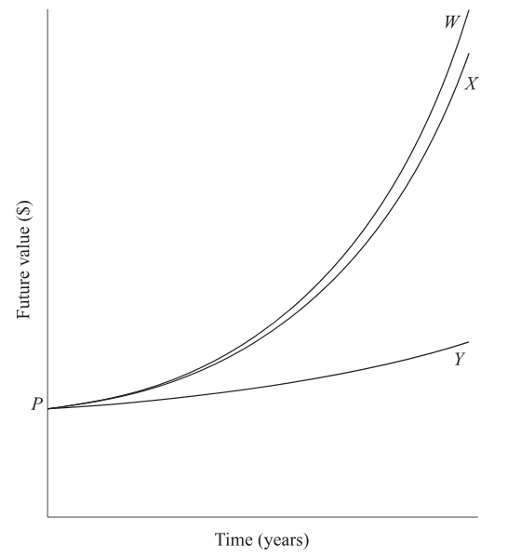
The graph shows the future values over time of $P,
invested at three different rates of compound interest.
Which option correctly identifies each graph?
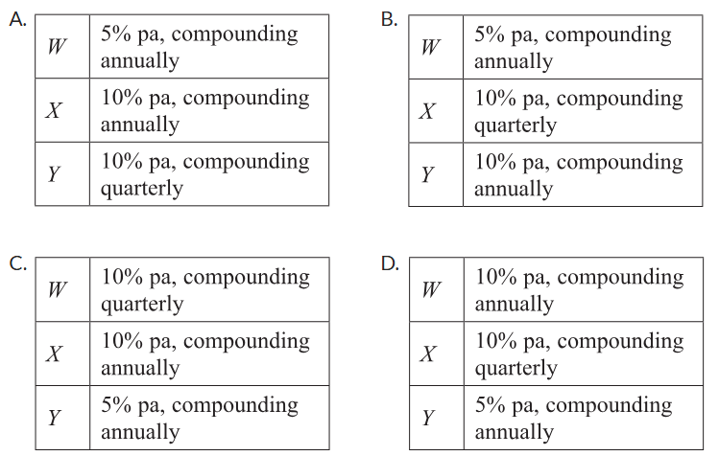

Higher interest rates increase faster.
More frequent compounding periods increase faster.
C

- 2008 HSC Standard 2 Band 4
Heidi’s funds in a superannuation scheme have a future value of $740 000 in 20 years’ time. The interest rate is 4% per annum and earnings are calculated six-monthly.
What single amount could be invested now to produce the same result over the same period at the same interest rate?

$$740 000=PV{\left(1+\frac{0.04}{2}\right)}^{20×2}$$
$$PV=\$335 138.91$$
- 2022 HSC Standard 2 Band 5
In ten years, the future value of an investment will be $150 000.
The interest rate is 4% per annum, compounded half-yearly.
Which equation will give the present value of the investment?
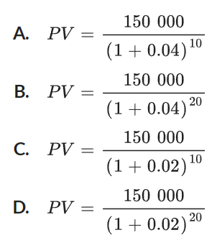

$$150 000=PV{\left(1+\frac{0.04}{2}\right)}^{10×2}$$
D
- 2021 HSC Standard 2 Band 5
Nina plans to invest $35 000 for 1 year. She is offered two different investment options.
Option A: Interest is paid at 6% per annum compounded monthly.
Option B: Interest is paid at $r$% per annum simple interest.
Calculate the future value of Nina's investment after 1 year if she chooses Option A.

$$FV=35000{\left(1+\frac{0.06}{12}\right)}^{1×12}$$
$37 158.72
Find the value of $r$ in Option B that would give Nina the same future value after 1 year as for Option A. Give your answer correct to two decimal places.

$$I=Prn$$
$$2158.72=35000×r×1$$
$$r=6.17\%$$
- [Continuous Compounding Problem]
As we have seen, the more frequent the compounding period, the more interest we get.
But is there a limit?
An account starts with $1 and pays 100% interest p.a.
For each of these, answer to 5 d.p.
  - Compounding annually: $1{\left(1+1\right)}^{1}=$
$2
  - Compounding monthly. $1{\left(1+\frac{1}{12}\right)}^{12}=$

$2.61303…
  - Compounding weekly.

$2.69259…
  - Compounding daily.

$2.71456…
  - Compounding each minute.

$2.71828…
  - Type the number $e$ into your calculator, what do you notice?

$$e=2.71828…$$

Depreciation

- Depreciation
Depreciation is the reverse of compound interest, value decreases by a percentage yearly.
Salvage value is the asset value after depreciation.

$\begin{matrix}initial \\ value\end{matrix}$ $\begin{matrix}number of \\ periods\end{matrix}$

$$S=V_{0}{\left(1-r\right)}^{n}$$

$\begin{matrix}salvage \\ value\end{matrix}$ $\begin{matrix}depreciation rate \\ per period\end{matrix}$

- Example Calculate salvage value from reducing balance depreciation
$r=0.1$
A car depreciates at 10% p.a. Calculate the salvage value of a $60 000 car after 3 years.
$V_{0}$ $n$
$S=V_{0}{\left(1-r\right)}^{n}$
$=\$60 000{\left(1-0.1\right)}^{3}$
$=\$43 740$

- Guided Practice
- Calculate the salvage value of a laptop that initially cost $2500 after 4 years of depreciation at 15% p.a.  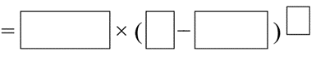  $FV=PV{\left(1-r\right)}^{n}$  $=$ ……………………………………  $1305.02 | - Calculate the salvage value of office equipment of $125 000 depreciating at 12.5% p.a. over 7 years.  $FV=PV{\left(1-r\right)}^{n}$  $=$ ……………………………………  $49 086.99

Foundation
- A car worth $20000 loses 15% in value every year.
How much will it be worth at the end of 5 years?

$FV=PV{\left(1-r\right)}^{n}$

$=$ ……………………………………
$8874.11
- Find the value of a photocopier after 5 years if its purchase price was $2850 and it depreciates by 20% per year.

$FV=PV{\left(1-r\right)}^{n}$

$=$ ……………………………………
$933.89
- A phone that cost $950 depreciated to a value of $520. How much did it depreciate by?

$FV=PV{\left(1-r\right)}^{n}$

$=$ ……………………………………
$430
- A new car that costs $30 000 depreciates by 20% of its value each year.
  - Calculate the car’s value after 4 years.

$FV=PV{\left(1-r\right)}^{n}$

$=$ ……………………………………
$12 288
  - How much did it depreciate by in that time?

$17 712

Development
- A new car that costs $25 500 depreciates by 18.5% of its value each year.
  - Calculate the car’s value after 2 years.

$16 937.74
  - How much did it depreciate by in that time?

$8562.26

  - Calculate the value after 3 years of a new computer that costs $4000 and depreciates by 25% of its value each year.

$1687.50
  - How much did it depreciate by in that time?

$2312.50
- A new car that costs $130 000 depreciates by 20% of its value at the start of each year.
  - Calculate the car’s value after 30 years.

$160.93
  - Will its value ever reach zero?

No, its value will never actually reach zero. There will always be some fraction of value left, though it becomes extremely small after many years.
- Sarah buys a car that depreciates at the rate of 20% per annum. After six years the car has a salvage value of $6400. How much did Sarah pay for the car, to the nearest dollar?

$24 414
- A new grand piano costs $32 000 and depreciates by 15% of its value each year.
Find how long it will take for the piano to depreciate to $16 000. Answer to the nearest year.

4 years
- A hatchback vehicle was purchased for $16 980 three years ago.
By using declining-balance depreciation, the current value of the vehicle is $9614.
What is the annual percentage rate of depreciation, correct to two decimal places?

17.27%
- The price of a new boat is $28 000. It depreciates by 20% of its value each year.
Find how long it will take for the boat to depreciate to $11000. Answer to the nearest year.

4 years
- Annie buys a car. After 6 years of declining-balance depreciation at 20% p.a., the value of the car is $18874.37. How much did she pay for the car, to the nearest dollar?

$72 000
- Philip and Amy spent $200 000 on a luxury car 7 years ago. Its current value is $104 350.
Using the declining-balance method, find the percentage depreciation rate over this period.
Answer correct to one decimal place.

8.9%
- Jessica invested $18 820 to buy a new car for her business.
How many years would it take for this car to depreciate to $4520?
Assume declining-balance method of depreciation with a rate of depreciation of 30%.
(Answer to the nearest year.)

4 years

Mastery
- A fitness centre has purchased a rowing machine for $3900.
The machine depreciates according to the declining-balance method at 15% p.a.
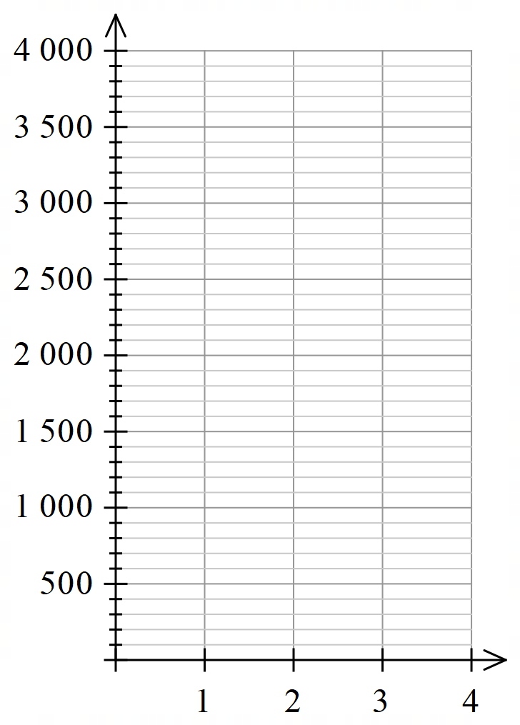
  - Complete the table then sketch the graph.
Years  $$n$$ | Salvage value $S$
1 | $3900
2 | $3315
3 | $2817.75
4 | $2395.09
5 | $2035.82

  - Explain why the graph is not a straight line.

The graph is of exponential decay.
A linear relationship would show constant change,
but with declining-balance depreciation,
the actual dollar amount of depreciation changes each year.

- The value of office furniture is shown by the graph. The furniture depreciates at 22% p.a.
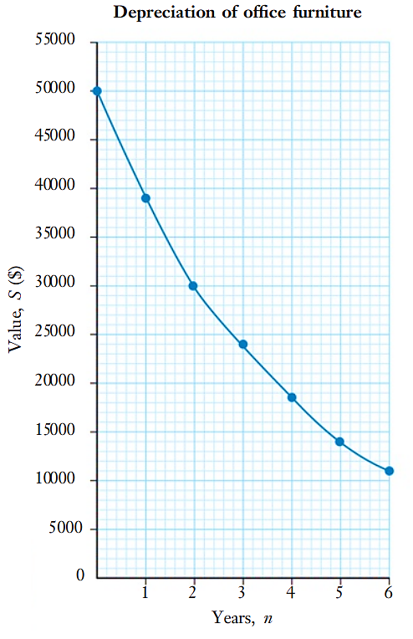
  - How much did the furniture cost?
$50000
  - How much did it depreciate between year 1
and year 2?

$9000
  - Use the salvage value formula to find the value of the furniture after 8 years.

$$\$6850.57$$

- Write down a scenario that could explain each of the following lines of working for compound interest and depreciation. Assume annual compounding periods.
- $300{\left(1.07\right)}^{12}$  $300 invested for 12 years at 7% p.a., compounding annually. | - $300{\left(1.02\right)}^{36}$  $300 invested for 36 years at 2% p.a., compounding annually. | - $1000{\left(1.005\right)}^{48}$  $1000 invested for 48 years  at 0.5% per year, compounding annually.
- $1000{\left(0.95\right)}^{5}$  A $1000 asset depreciating for  5 years at 5% p.a., | - $9000{\left(0.8\right)}^{3}$  A $9000 asset depreciating for  3 years at 20% p.a., | - $1500{\left(0.805\right)}^{13}$  A $1500 asset depreciating for  13 years at 19.5% p.a.,

- A car costs $12 000.
- Helen pays a deposit of 30% and pays the rest in 12 monthly instalments at 0% interest. How much does she pay each month?  Deposit: $0.3×12 000=\$3600$  Amount left to pay: $\$8400$  $$8400÷12=\$700$$ | - The price of the car decreases by 13%. What is the new price?  $$12000×0.87=\$10 440$$
- Steven sells the car for $14880.  What is his percentage profit?  Profit: $14 880-12 000=2880$  $$\frac{2880}{12 000}×100=24\%$$ | - The value of the car depreciates by 7% each year. How much is it worth after 5 years?  $$S=12000{\left(0.93\right)}^{5}=\$8348.26$$
- The amount of arable land in a region is decreasing by 6% pa due to the encroachment of desert and soil erosion. If the arable area is currently 2 million hectares, what will it be in 20 years’ time? Give your answer to the nearest 1000 hectares.

$$2 000 000{\left(0.94\right)}^{20}≈580 000 ha$$
- A 35 mg piece of radioactive substance is decaying at a rate of 0.5% per year.
Determine the mass remaining after 400 years to one decimal place.

$$35{\left(0.995\right)}^{400}≈4.7 mg$$
- The temperature in a water tank decreases by 7% per hour. The initial temperature was 70°C. What was the temperature after a day (to one decimal place)?

$$70{\left(0.93\right)}^{24}=12.3°C$$
- Leo has spent $27 000 on equipment to set up his painting business. The equipment depreciates at 18% p.a. Find how long it will take for the equipment to depreciate by a total of $20 000. Answer to the nearest year.

Depreciate by $20 000 means salvage value of $27 000 - $20 000 = $7000
$$\$7000=\$27000{\left(0.82\right)}^{n}$$
7 years
- 2019 HSC Standard 2 Band 4
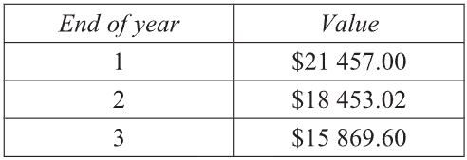
A new car is bought for $24 950. Each year the value of the car is depreciated by the same percentage. The table shows the value of the car, based on the declining-balance method of depreciation, for the first three years.
What is the value of the car at the end of 10 years?

Percentage change: $\frac{Change}{Original}$ $×100$
$\frac{18453.02-21457}{21457}$ = $14\%$ decrease per year
$$S=24950{\left(0.86\right)}^{10}=\$5521.47$$
- 2020 HSC Standard 2 Band 5
An asset is depreciated using the declining-balance method with a rate of depreciation of 8% per half year. The asset was bought for $10 000.
What is the salvage value of the asset after 5 years?

$$S=10000{\left(1-0.08\right)}^{10}=\$4343.88$$

